Library Menu
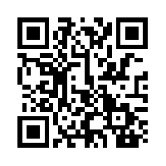
Mon-Fri: 6:45 to 5:00 Online resources: 24/7

Appetizers
Databases E-books Mastery Manager
Print books Graphic Novels Group project space
OERs Certified Librarian Literary Events
Entrees
Information Literacy Skills – one day class
A delightful blend of online evaluation skills, citing sources, using databases and other strong research practices all briefly covered in one mod
Information Literacy Skills – workshop style
A thorough covering of online evaluation skills, citing sources, using databases and other strong research practices in a 2-4 day class scheduled to fit your particular curricular needs
Co-taught unit **
Uniquely designed to best fit your students’ information needs and most strongly support your curriculum. Less work for you as the librarian takes on half the teaching and grading! Enjoy watching your students benefit from this collaborative effort.
Reading List Creation
Capture your students’ interest and excitement with a vivid Required or Outside Reading list annotated by your local, friendly librarian! Comes with plenty of electronic access as a Pinterest board, QR code link, Weebly, pdf link and so much more!
**Most valuable and beneficial for teachers and students
A la carte classes
Google skills and tricks Citing sources CRAP online evaluation
Working bibliography Book talks Wikipedia skills
Spotting fake news Digital citizenship Weebly and other online tools
